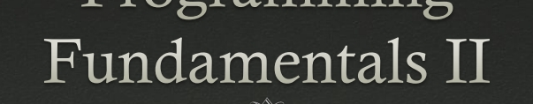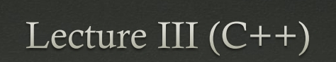

Recap

* Basic about the course
* Programming
* What is C++??
* Environment for C++
* References



* IDE: Codeblocks, Visual Studio 2013+  Extensions of C++: .cpp .cxx .cc .C  #include<iostream>
* Input : cin>> variable
* Output: cout<<variable;
* using namespace std;



Practice

 Write a C++ code that will print the following statements as like it:

I Love C++.

But don’t want to practice.

 Write a C++ code that will take two inputs from keyboard and calculate the summation, subtraction, multiplication, division of these two inputs and print the results.



Outlines (C++)



Tokens

Identifiers

Keywords

Constants

[Operators](OPerator in c++.pdf)

[Variables](Variables and Data Type.pdf)

[Data Types](Variables and Data Type.pdf)



Modifiers

[Decision making](Conditional Statements C++.pdf) (Conditional Statement)

[Loops](Loop Statements in C++.pdf)

Functions

Arrays

String



Keywords in C++

|  |  |  |  |
| --- | --- | --- | --- |
| asm | else | new | this |
| auto | enum | operator | throw |
| bool | explicit | private | true |
| break | export | protected | try |
| case | extern | public | typedef |
| catch | false | register | typeid |
| char | float | reinterpret_ca  st | typename |
| class | for | return | union |



|  |  |  |  |
| --- | --- | --- | --- |
| Const | friend | short | unsigned |
| const_cast | goto | signed | using |
| continue | if | sizeof | virtual |
| default | inline | static | void |
| delete | int | static_cast | volatile |
| do | long | struct | wchar_t |
| double | mutable | switch | while |
| dynamic_cas  t | namespace | template |  |



Constants

* Constants are also called literals.
* Constants can be any of the data type.
* It is considered best practice to define constants using only upper-case names.
* Unlike variables, **constants** never change in value.  Examples

const int KILLING_ZOMBIE_BONUS = 5000; #define BONUS 500



References

 [www.w3schools.in/cplusplus-tutorial](http://www.w3schools.in/cplusplus-tutorial)